# Demo Overview: Automated QR Code Generation

## 1. Executive Summary

This document outlines a proof-of-concept demonstration for an automated asset identification system. The demo showcases a powerful automation engine that instantly generates QR codes for physical assets by retrieving data from a master list. This process entirely replaces time-consuming manual data entry and labelling, highlighting a direct path to reducing operational time, minimizing errors, and improving overall efficiency in asset management.

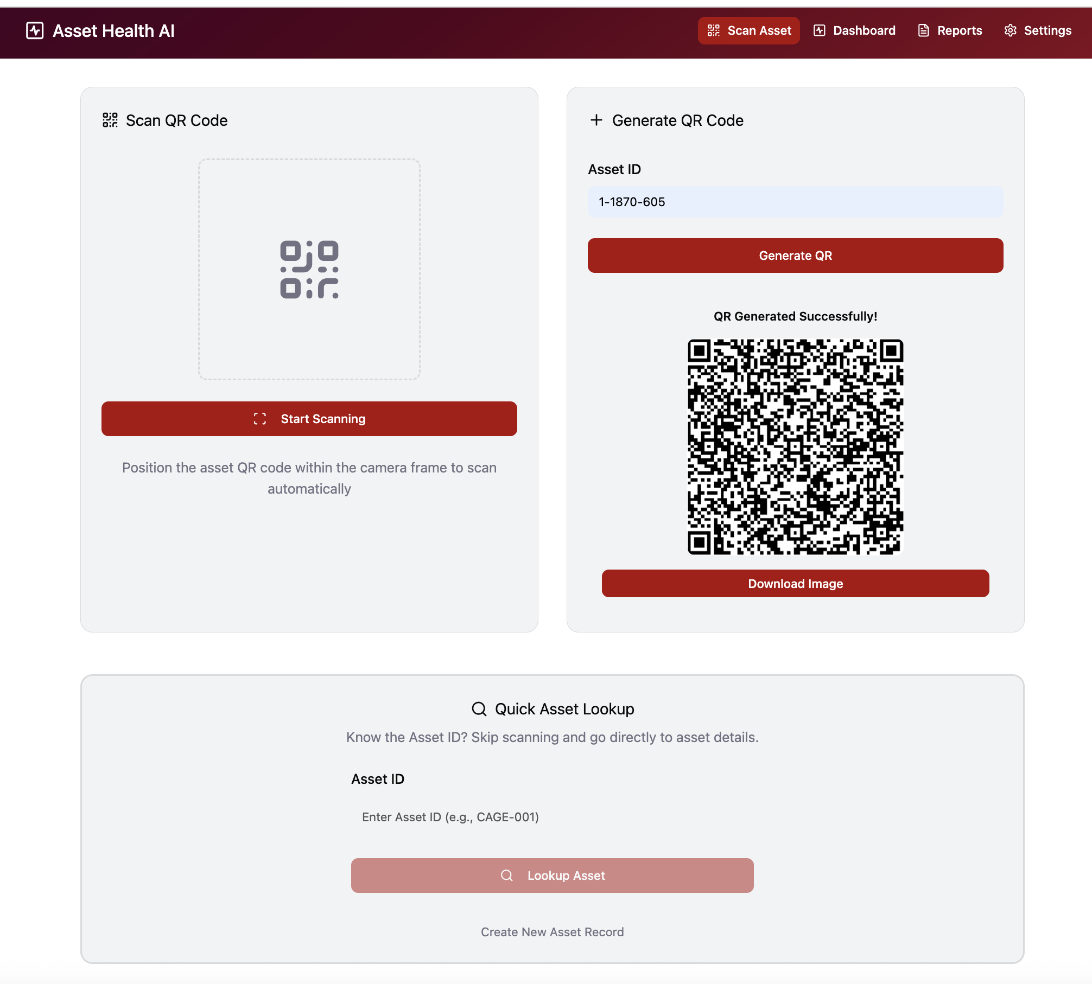

Figure 1 Landing Page: Users generate an asset label using the Asset ID. Once created, the QR code is scanned to navigate to the Asset Details Page.

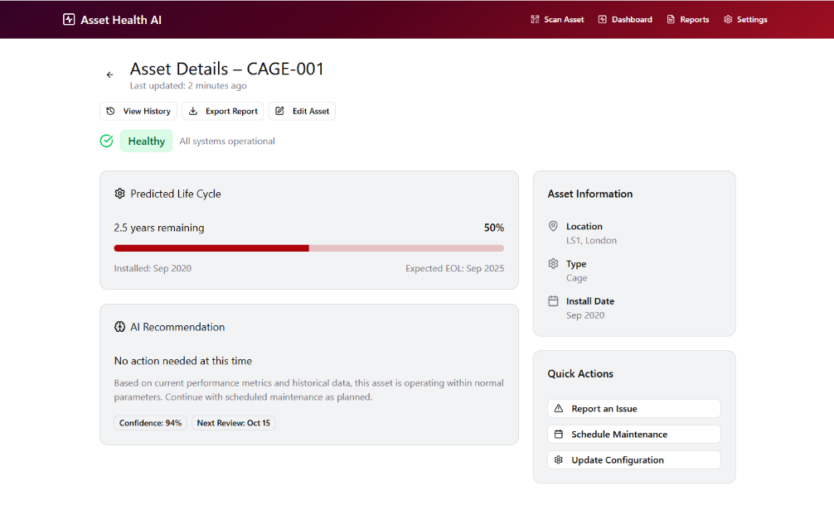

Figure 2 Displays information for the scanned or searched asset, including health status (based on operational state, staging, decommissioning status, or site end-of-life) A visual lifecycle bar shows expected asset longevity and AI-based maintenance suggestions. Users can view key details (location, type, install date), export a PDF report, and use quick actions to report issues, schedule maintenance, or update configurations—each triggering an RPA bot to create a support ticket.

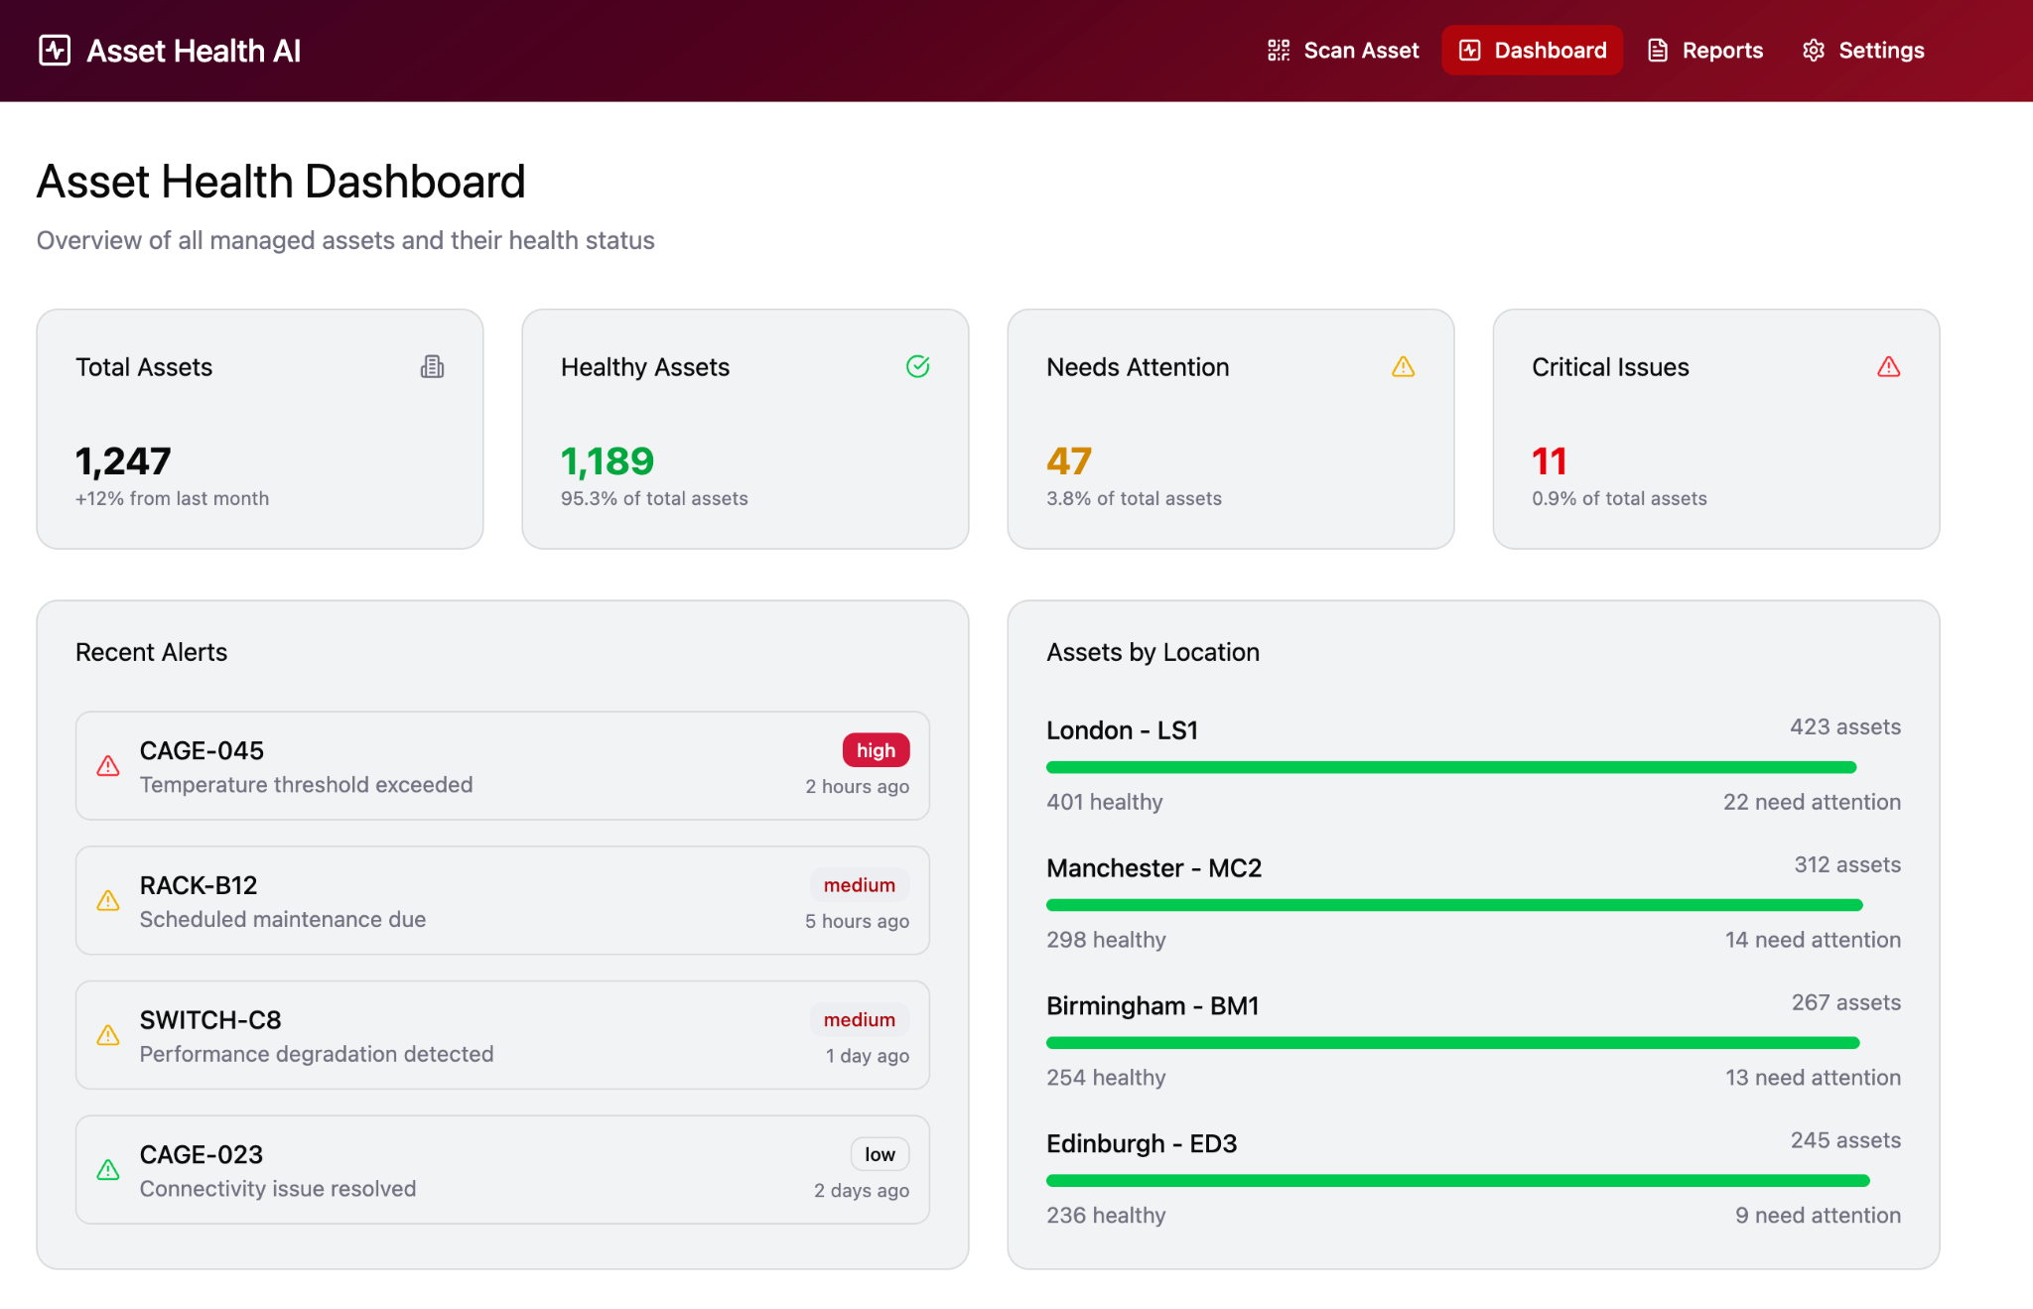

Figure 3 Powered by Maximo API, this dashboard provides real-time insights into asset inventory and health status. It displays total assets, their criticality levels (healthy, needs attention, critical), recent alerts, and asset distribution by location—enabling

## 2. The Problem: Manual Asset Labelling

In large-scale operational environments, the process of creating identification labels for assets is a significant bottleneck. It requires technicians to manually look up asset data, transcribe it, and use a tool to generate a QR code or label. This manual workflow is slow, prone to transcription errors, and scales poorly, leading to increased labour costs and delays.

## 3. The Solution: An Automated Workflow

This demonstration presents an automated solution that transforms the asset labelling process. By triggering a simple request, the system's automation engine performs all the necessary steps without human intervention.

### Demonstration Workflow

The demo showcases the primary capability through the following automated steps:

1. **Request Initiation:** The process starts when a request is sent to a dedicated endpoint, specifying a unique asset ID.
2. **Automated Data Retrieval:** The automation engine receives the ID, accesses a master data source, and instantly retrieves all relevant information for that specific asset.
3. **Instant QR Code Generation:** The retrieved data is formatted and used to generate a unique QR code.
4. **Label Delivery:** A ready-to-use QR code image is returned, completing the entire process in seconds.

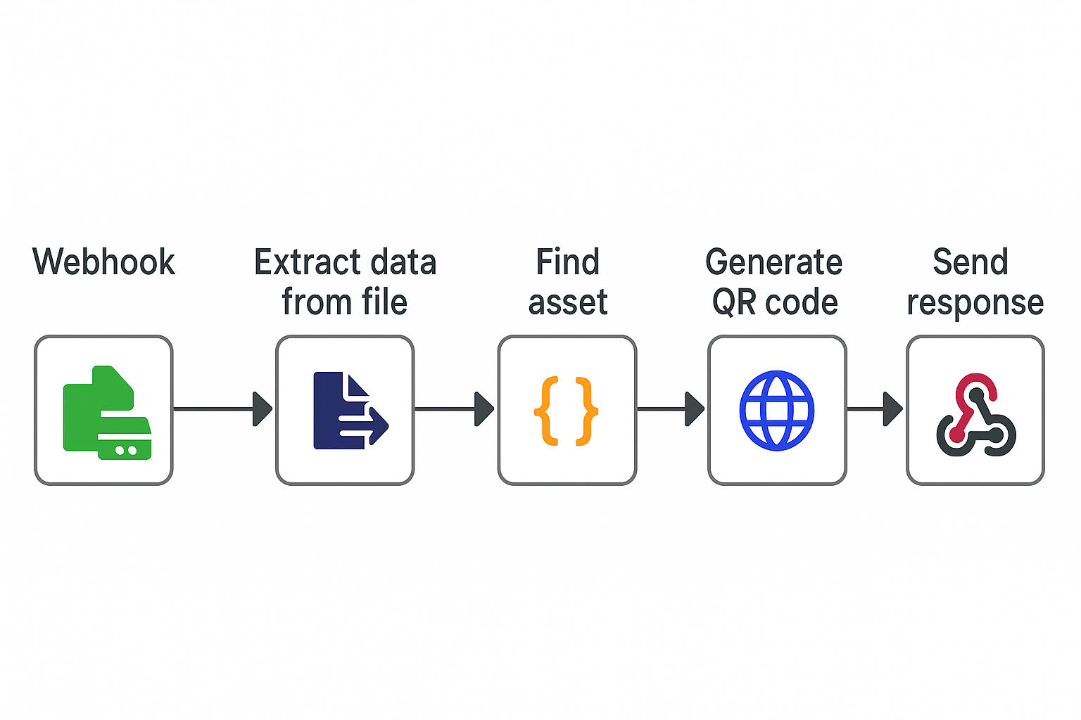

## 4. Technology Stack Used in the Demo

The proof-of-concept is built on a modern and robust technology stack:

* **Automation Engine:** n8n
* **Containerization:** Docker
* **Web Interface (for visualization):** React & TypeScript

## 5. Key Benefits Demonstrated

The functionality shown in this demo provides immediate and tangible benefits:

* **Drastic Time Reduction:** Reduces the time required for asset labelling from several minutes of manual work to just seconds per asset.
* **Significant Cost Savings:** Eliminates labour costs associated with manual data lookup, transcription, and label creation.

**Manual Labelling Assumptions:**

* Time per asset: 5 minutes
* Labour cost: £0.50 per minute
* Total cost per asset: £2.50
* Total cost for 10,000 assets: £25,000

**Automated Labelling Assumptions:**

* Time per asset: 5 seconds (0.083 minutes)
* Labour cost: £0.50 per minute (assumed negligible for automation, but included for comparison)
* Total cost per asset: £0.0417
* Total cost for 10,000 assets: £416.67

Automating the asset labelling and management process for **10,000 assets** is estimated to save approximately **£30,729.17**.

* **Elimination of Human Error:** Automating the data transfer process ensures that QR codes are 100% accurate and consistent with the source data.
* **Proven Scalability:** The containerized architecture demonstrates a model that can be easily scaled to handle thousands of assets without a proportional increase in manual effort or cost.